Co-Producing Equitable Solutions to Septic System Failures: Towards a Regional Resilience Hub

Vision, Justification, and Impact

Theme and Rationale
Across much of the Mid-Atlantic and Southeastern United States, decentralized septic systems are reaching a breaking point[1]–[5]. In rural and coastal communities, decentralized septic systems that were once considered a reliable and affordable form of household wastewater management are increasingly failing under the combined pressures of age, saturated soils, and climate stressors[6], [7]. Rising groundwater tables reduce the vertical separation needed for proper effluent treatment, storm-driven flooding saturates drainfields, and more intense rainfall increases the frequency of system overloads. Sea level rise compounds these pressures by pushing saline water into shallow aquifers and permanently elevating groundwater levels, undermining thousands of systems that were once marginally viable[3], [8]. Without intervention, these stressors will continue to expand the impact of septic failures, turning localized breakdowns into chronic regional problems[9].
Unlike urban sewer networks, septic systems are privately owned and dispersed, leaving responsibility to individual households, many of whom lack financial resources, technical expertise, or information. Failures carry consequences far beyond the household: untreated wastewater contaminates aquifers and private wells, adds nutrients and pathogens to estuaries, and threatens both health and ecosystems. Nitrate contamination is linked to cancer and infant health risks, while bacterial and viral exposure contributes to gastrointestinal illness[9], [10]. Failing septic systems already contribute an estimated six percent of nitrogen loads to the Chesapeake Bay, with far higher shares in local waters[11]. In some coastal communities, shellfish harvest areas have been closed due to bacterial contamination, resulting in both ecological and economic losses [12]. These cascading impacts are particularly acute in underserved rural areas, where exposure is high but resources for mitigation are limited. The Eastern Shore Health District’s 2023–2024 Community Health Assessment underscored these vulnerabilities, citing poor water quality, inequitable access to care, and high rates of uninsured residents[10].
Historically underserved communities rely disproportionately on private wells and septic systems[11], yet they are least able to absorb the financial burden of repairs or conversions[13], and are frequently excluded from infrastructure planning processes that shape investment decisions[14]. Governance of septic systems is fragmented, with state health departments maintaining only partial records, local agencies managing permits, and no single entity accountable for coordinated adaptation[11]. Regulations often focus on penalizing noncompliance rather than supporting proactive maintenance or equitable transition, reinforcing a cycle of hidden failures and widening inequities[15]. Left unchecked, climate-driven stressors will magnify these vulnerabilities, transforming what has long been treated as a private household problem into a systemic resilience challenge for entire regions. Addressing this challenge demands more than technical fixes: it requires integrated approaches that link hydrologic science, engineering, public health, social science, and community engagement. Only by coupling early warning of vulnerabilities with decision-support tools, building the data infrastructures to trace cascading risks, and developing financing and governance pathways for equitable transitions can we reframe septic failure as an opportunity to advance climate-ready infrastructure. By taking up this challenge, this project aims to transform septic failure from an under-recognized risk into a catalyst for equitable, climate-ready infrastructure in rural America, while positioning the UVA Environmental Institute as a leader in translational, community-engaged climate resilience research.

Building on the NSF Climate Equity Project

Insights from the ESVA Climate Equity Project
Responding to the cascading risks described above requires moving from diagnosis to action. This proposed project builds directly on the Eastern Shore of Virginia (ESVA) Climate Equity project, funded through the National Science Foundation’s Coastlines and People (CoPe) program. Launched in 2021, the ESVA Climate Equity project is a five-year effort that combines advanced geophysical modeling, stakeholder network analysis, and participatory engagement to understand the vulnerabilities of the communities across ESVA. A central output is the ESVA Livability Tool, which integrates scientific data layers, including but not limited to storm surge and flood risk, flood-induced road disruptions, and groundwater level, into a decision-support platform that is primarily designed for local government officials. Alongside this scientific work, the project engaged residents, nonprofits, and local governments through workshops, interviews, and participatory mapping to surface community-defined concerns. In those conversations, septic system failure has consistently emerged as a critical issue. In fact, in the project second community workshop in February of 2024, septic failure was identified as the third most pressing concern in a participatory exercise (Figure 1).
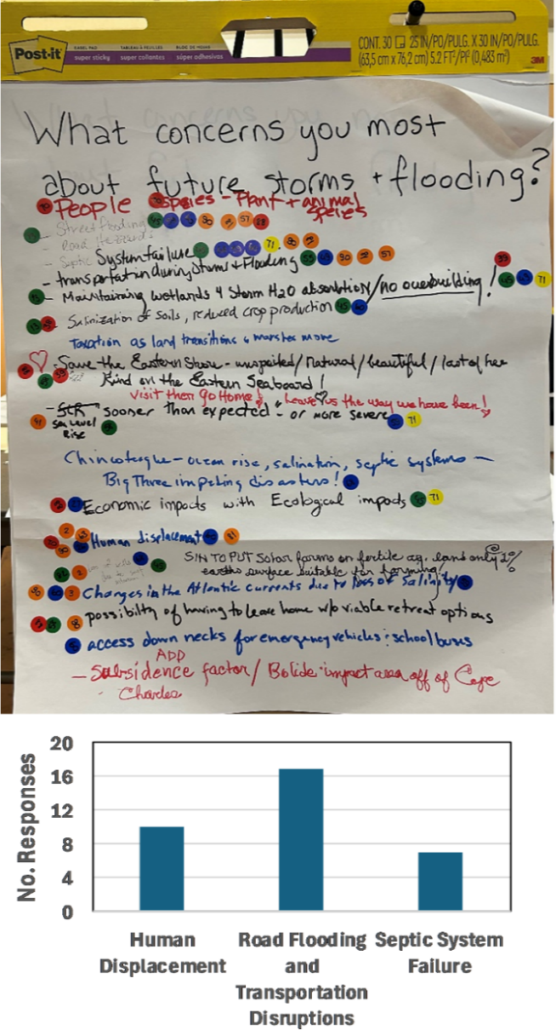
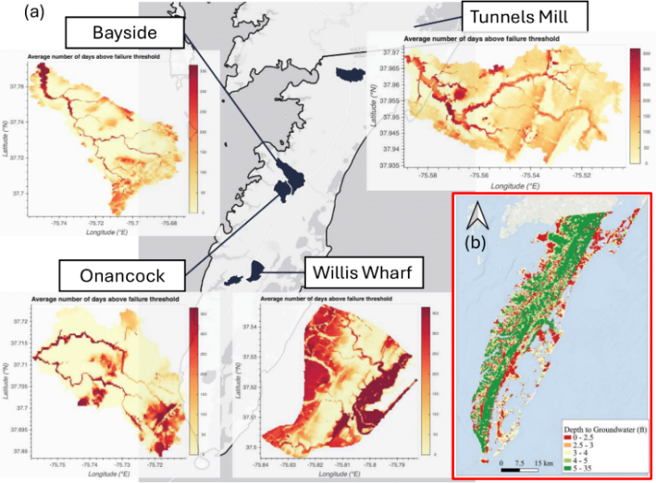
The ESVA Climate Equity project has provided critical diagnostic insights and modeling capacity (Figure 2), but it was not designed to carry those insights through to implementation. Furthermore, our understanding of septic vulnerabilities remains limited in several important ways. First, most modeling studies do not capture how risks shift under future climate conditions or how real-time monitoring could provide early warning. Second, while existing studies identify areas of concern, they do not provide households or local governments with tools to compare adaptive wastewater alternatives or evaluate tradeoffs in cost, feasibility, and equity. Third, cascading environmental and health risks associated with septic failures remain largely unquantified. Finally, financing and governance pathways for equitable transitions have not been systematically explored, leaving households and local agencies without clear strategies for implementation or scaling. This proposal responds to those limitations by demonstrating proof-of-concept monitoring and early warning, co-developing a decision-support platform for adaptive wastewater alternatives, laying the groundwork for environmental and health risk assessment, and initiating pathways for equitable financing and regional coordination.
Figure 1. ESVA Community’s top concerns related to flooding. After the community highlighted flooding as one of their immediate concerns in ESVA Climate Equity project first community workshop (Feb. 2023), we asked the participants of our second workshop (Feb. 2024) to tell us more about what concerns them the most about storms and flooding.
Figure 2. Sea level rise and higher groundwater levels increase risk of septic failure. (a) shows potential septic failure in four watersheds across the Eastern Shore of Virginia chosen based on community interests. The analysis was conducted for the 2020-2023 period at the 30-m spatial resolution and the subplots show the average number of days per year where the groundwater level exceeds the failure threshold (600mm) of a typical septic system. (b) shows depth to groundwater modeled using SEAWAT for year 2023.

Translational Pathway: A Four-Stage Vision
To make this translational pathway explicit, we frame our work across four interconnected stages, each with a distinct purpose and rationale. Together, these stages chart a trajectory from identifying septic vulnerabilities to advancing climate resilience of wastewater systems in coastal rural communities.
Diagnostic Stage (ESVA Climate Equity project, current): This stage focused on building the foundation of science and trust. It identified septic failure as one of the community’s top resilience concerns, produced participatory maps of vulnerabilities, advanced groundwater and storm surge modeling, and created the ESVA Livability Tool to integrate multiple risk layers. Co-PI Culver’s groundwater modeling and analyses of septic vulnerabilities have provided an initial understanding of risks on the Eastern Shore, while complementary work by co-PI Mitchell in Virginia’s Northern Neck and Middle Peninsula used septic suitability mapping to identify potential sites for community systems. These efforts provided a critical diagnostic base but were not designed to carry insights through to implementation.
Action Stage (This proposal, short term): This stage translates diagnostic insights into actionable tools and demonstrates feasibility. We will prototype real-time monitoring, community-based reporting, and AI-enabled mapping as a proof of concept for early warning, showing how timely detection can prevent failures from cascading into contamination. In parallel, we will co-design and test a decision-support platform that allows households and local governments to compare clustered, onsite, and nature-based wastewater alternatives. Beyond these core demonstrations, the Action Stage also undertakes essential groundwork for future efforts by digitizing initial septic and well records, identifying data and monitoring gaps, mapping financing and permitting barriers, and engaging early regional partners.
Expansion Stage (Mid-term future): Building on the proofs of concept and groundwork established in the Action Stage, this phase will broaden scope and scale. It will extend digitization of septic and well records across jurisdictions, develop robust data infrastructures for exposure assessment, and launch targeted sampling campaigns in hotspot areas to begin quantifying cascading environmental and public health risks. It will also move beyond preliminary financing gap analysis to design and test equitable financing and policy mechanisms for wastewater transitions, positioning the monitoring framework for wider deployment as technologies become more affordable.
Regionalization Stage (Long-term vision): The final stage envisions a Mid-Atlantic Coastal Wastewater Resilience Hub that links research, practice, and policy across Virginia, Maryland, Delaware, and North Carolina. At this stage, monitoring systems could be expanded through industry partnerships and large-scale investment, complementing decision-support platforms, data infrastructures, and financing models. The hub will foster comparative learning, regional coordination, and equitable implementation of wastewater transitions, positioning the Mid-Atlantic as a national model for climate adaptation.

Geographic Justification
The Eastern Shore of Virginia (ESVA) is the anchor locality for this project and the focus of the Action Stage. Several features make ESVA uniquely suited as a living laboratory. More than 18,000 households in Accomack and Northampton Counties depend on septic systems, many of which are decades old and located in areas with high groundwater tables and poor soil percolation capacity[10], [11]. These vulnerabilities are amplified by some of the fastest rates of relative sea level rise on the U.S. East Coast, shallow aquifers that directly intersect with drainfields, and recurring flooding events that saturate soils[16]. At the same time, ESVA has higher poverty rates and a larger share of uninsured households than the Virginia state average, leaving many residents without the financial resources or institutional support to address failing systems. Through the ESVA Climate Equity project, durable partnerships have already been built with communities, nonprofits, local government agencies, and the Accomack–Northampton Planning District Commission, ensuring that this proposal begins from a position of trust and responsiveness.
While ESVA is the starting point, the challenges it faces are broadly representative of rural coastal regions across the Mid-Atlantic. Similar vulnerabilities are present across coastal Virginia, Maryland’s coastal plain, Delaware’s low-lying agricultural communities, and the North Carolinas’ barrier island regions. Co-PIs Reilly (University of Maryland) and Mitchell (VIMS) bring expertise from Maryland’s and Virginia’s coastal plain regions, allowing lessons from ESVA to be directly compared and extended across similar settings in the Mid-Atlantic. In this way, ESVA serves not only as a scientifically and socially compelling anchor site, but also as the foundation for building a scalable framework to inform wastewater resilience throughout the region.

Integrative Framework and Research Questions
The overarching objective of this project is to advance the resilience of decentralized wastewater systems in rural coastal communities by developing and testing a translational framework that couples early warning of septic vulnerabilities with decision-support tools for adaptive wastewater transitions, while laying the data foundations needed to address cascading environmental and health impacts in future phases. The proposed project is organized around four interconnected thrusts underpinned by a robust strategy for engagement and translation which collectively together form an integrative framework for advancing both fundamental knowledge and actionable solutions. Each thrust aligns with one or more stages of our broader vision, ensuring continuity from community-identified concerns to regional transformation, and is guided by specific research questions.

Research Thrusts and Scientific Integration
Thrust 1: Real-Time Monitoring and Early Warning – Proof of Concept (Action Stage)
Septic failures often remain invisible until they cascade into well contamination, estuarine pollution, or public health crises. Building on Diagnostic Stage insights, this thrust will demonstrate a proof-of-concept monitoring and early warning system that integrates prototype sensors, community reporting, and AI-enabled mapping. The goal is not wide-scale deployment, which remains cost-prohibitive, but a practical demonstration of feasibility that can inform future expansion through larger grants, industry partnerships, and lower-cost technologies. This thrust is guided by the following research questions:
- RQ1.1: What hydrologic and environmental signals reliably precede septic system failure in flood-prone, shallow-aquifer regions, and how can these signals be formalized into predictive indicators of failure?
- RQ1.2: How does integrating community-reported observations with AI-enabled monitoring affect the predictive accuracy and legitimacy of septic vulnerability models compared to sensor-based models alone?
Thrust 2: Decision Support for Adaptive Wastewater Transitions (Action Stage)
Local governments and households often lack clear, accessible tools to proactively assess septic vulnerabilities and evaluate adaptive wastewater alternatives, particularly under changing conditions. This thrust will extend the groundwater and septic vulnerability modeling underway in the ESVA Climate Equity project, integrating new monitoring data, scenarios, and socio-demographic indicators to generate maps of septic system failure probability and vulnerability hotspots across the region. These layers will form the backbone of a decision-support platform that compares the performance of adaptive wastewater options, including enhanced onsite systems, clustered and decentralized solutions, nature-based approaches, and sewer extensions where feasible. Developed through iterative engagement with local partners and stakeholders, the tool will provide both households and local governments with a transparent and actionable framework to guide wastewater transitions. While the platform in this project focuses on failure risk, direct costs, and feasibility, Thrust 3 will augment it with cascading environmental and public health endpoints, enabling a more complete accounting of risks and consequences. This thrust is guided by the following research questions:
- RQ2.1: Where are the current and emerging hotspots of septic system failure risk on the Eastern Shore, and how are these hotspots projected to shift under alternative sea level rise scenarios?
- RQ2.2: Which decentralized wastewater alternatives most effectively reduce modeled failure risk relative to lifecycle cost and feasibility in coastal, shallow-aquifer regions?
- RQ2.3: How does the explicit framing of risk, cost, and equity tradeoffs in decision-support tools shape infrastructure choices made by households, planners, and agencies?
Thrust 3: Cascading Environmental and Public Health Risks (Expansion Stage)
Thrust 3 aims to broaden the scope of risk assessment by examining how septic failures cascade into environmental and public health consequences. Failures can contaminate shallow groundwater and private drinking water wells, elevate nutrient loads in estuaries, and expose households to health risks that are difficult to detect until it is too late and extremely costly to mitigate once failures occur. These cascading impacts underscore the importance of proactive interventions, such as the early warning systems (Thrust 1) or transitions to alternative systems (Thrust 2), by revealing the full costs of inaction. However, advancing this line of inquiry requires more robust data, monitoring, and modeling to trace how system failures translate into exposure pathways and long-term risks. In this project, we focus on enabling groundwork by developing preliminary data infrastructures, identifying critical gaps, and strengthening collaborations with agencies and research partners who can carry forward field sampling and comprehensive exposure modeling in future stages.
Thrust 4: Equitable Financing and Scalable Implementation (Expansion & Regionalization Stages)
Thrust 4 addresses the intertwined challenges of financing and regional coordination that determine whether wastewater resilience solutions pursued in this project can be implemented equitably and at scale. Technical innovations alone will not succeed if underserved households and communities cannot afford them, or if fragmented permitting and policy frameworks restrict their adoption. Equitable financing models, shared investment mechanisms, and regional governance structures are therefore essential to lowering household barriers while enabling collective action across jurisdictions. This thrust envisions the creation of a regional hub for wastewater resilience that connects governments, agencies, and research partners in advancing financing strategies and institutional pathways. In this project, we take preliminary steps by assessing current financing and permitting challenges, identifying equity gaps, co-developing guiding research questions, and engaging potential partners who can help seed both financing mechanisms and regional coordination efforts in future stages.

Engagement and Translational Pathways
Community engagement is not an add-on but a central pillar of the integrative framework. Building on the participatory processes of the ESVA Climate Equity project, we will embed community partners at every stage of design, implementation, and translation. Our engagement strategy rests on three interlocking components:
- Community liaison team. Co-PI Wilson will lead the engagement activities, extending her role as community engagement lead for the ESVA Climate Equity project. She will be supported by a local team that includes Cora Baird (UVA Coastal Research Center (CRC) site director), Elizabeth Richardson (CRC Engagement Coordinator and ESVA native), and Alex Foxworthy (Eastern Shore Community College (ESCC) faculty and member of the Climate Equity community advisory committee). Together, this team provides deep local knowledge, trusted relationships, and a direct bridge between researchers and community. Their role extends across the full project: guiding recruitment of households for the monitoring demonstration; facilitating co-design and feedback for the decision-support platform; ensuring that data privacy, equity, and household benefits are prioritized throughout; and maintaining ongoing two-way communication between the project team, residents, and local agencies.
- Engagement in research activities. Community partners will not only identify problems but help shape solutions. For Task 1, households will be recruited to host prototype sensors, with modest participation incentives to support inclusion. The liaison team will work closely with participants to ensure clarity on what is being monitored (e.g., groundwater levels, soil saturation, septic tank levels), how data are transmitted and stored, and how results will be used to provide early warning rather than penalization. For Task 2, engagement will center on targeted interviews and small focus groups with end users, including residents, local governments, and planning staff, rather than one-time workshops. This iterative process will allow for refining vulnerability mapping, platform usability, and decision metrics based on community priorities.
- Capacity building and workforce development. Translating research into lasting community benefits requires building local capacity. Through collaboration with Dr. Foxworthy and ESCC, we will develop capstone projects that align with research activities and provide students with hands-on experience. Internship programs will connect ESCC and UVA students with local government agencies, where they can assist with septic data digitization, monitoring support, and platform testing. These activities help enhance the capacity of the local workforce for wastewater resilience and provide sustained assistance to resource-constrained agencies.
To ensure engagement is not only implemented but also evaluated as part of the research, we will explicitly examine how participatory processes and capacity-building activities influence legitimacy, usability, and long-term impact of project outputs. This will include longitudinal household surveys to track changes in trust and satisfaction among participating families, structured feedback from local agency partners, usability testing of the decision-support platform, and assessment of student learning outcomes from ESCC capstone projects and internships. These evaluations will provide systematic evidence of how co-production strengthens both scientific credibility and community legitimacy while also expanding local workforce capacity for wastewater resilience. This component of the research is guided by the following questions:
- RQ-E.1: How can longitudinal measures of trust capture the dynamics of community–researcher relationships?
- RQ-E.2: Which dimensions of participatory design most strongly shape the usability and adoption of the decision-support platform?
- RQ-E.3: What models of university–community college collaboration are most effective in building durable local workforce capacity?
Together, these thrusts and translational pathways form an integrative framework that couples scientific innovation with co-production and capacity-building, ensuring that technical advances are embedded within durable community relationships and positioned for scaling across the region.

Anticipated Impact
The proposed project will generate impacts at multiple scales. In the near term, it will deliver tangible tools for Virginia’s Eastern Shore: a proof-of-concept monitoring and early warning system that helps households and local agencies anticipate septic failures before they cascade, and a prototype decision-support platform that allows communities to compare wastewater alternatives. These outputs will address priorities identified directly by residents in the ESVA Climate Equity project and provide decision-makers with actionable information that is currently unavailable. Beyond specific tools, the project strengthens cross-institution collaborations while directly supporting local capacity. Workforce development components, including capstone projects and internships designed in partnership with ESCC, will equip students with skills in monitoring, data digitization, and decision-support, while providing much-needed technical assistance to local agencies. Just as importantly, this project represents a continuation of the five-year ESVA Climate Equity project. After engaging the community to diagnose challenges, we now focus on solutions and implementation. This progression responds directly to concerns often voiced by residents, that researchers leave once diagnostics are complete, without delivering meaningful impact, and instead, demonstrates a long-term commitment to reciprocity and trust. In the long term, the project will establish the foundation for a Mid-Atlantic hub for wastewater resilience. By building data infrastructures, testing adaptive tools, and developing pathways for equitable financing, the project sets the stage for scaling across Maryland, Virginia, and ultimately other coastal regions facing similar challenges. The combined emphasis on scientific rigor, co-production, and workforce capacity ensures that septic failure that has long been treated as a private household issue can instead become a catalyst for reimagining equitable, climate-ready infrastructure in rural America.

Research Plan and Integration of Partnerships

Team Integration, Collaborative Strategy, and Partnerships
Following the successful collaborative model established in the ESVA Climate Equity project, this proposal advances a use-inspired, interdisciplinary research effort grounded in long-term relationships with community partners. The UVA team is led by PI Shafiee-Jood, whose transdisciplinary research spans climate resilience, stakeholder-informed modeling, complex systems analysis, decision-making under uncertainty, and decision support systems. Co-PI Wilson leads our community engagement and co-production efforts and coordinates the community liaison team, building on her leadership in the ESVA Climate Equity project. Her expertise in participatory research and equitable planning ensures that research activities remain grounded in community priorities. Co-PI Culver brings extensive experience in water resources engineering, hydrological modeling, and stormwater management. She leads groundwater modeling and septic vulnerability assessments in the ESVA Climate Equity project and will co-lead the development of the adaptive wastewater platform. Co-PI Alemazkoor, an expert in AI, data sampling, and uncertainty quantification, contributes essential technical depth to the monitoring and early warning components of the research. She will lead the development of machine learning algorithms to support real-time vulnerability detection and forecasting. Together, this interdisciplinary team integrates engineering, data science, and community-based research to create a translational framework that is both technically innovative and socially legitimate.
This interdisciplinary core is strengthened by two external collaborators who bring complementary expertise and extend the geographic relevance of the project. Co-PI Mitchell of the Virginia Institute of Marine Science brings deep expertise in sea level rise, water quality, and coastal decision-making. Her research, including the Virginia Wastewater Data Viewer[17] and the Rural Septic Assessment platform[18], is especially relevant to this project, as both tools visualize septic system vulnerabilities and infrastructure challenges across Virginia’s coastal plain. While these tools do not currently include the Eastern Shore, they offer a model for integrating environmental and demographic data into decision-making. Mithcell therefore will contribute to Thrusts 1 and 2 and will play an important role in our expansion and regionalization efforts. Co-PI Reilly of the University of Maryland adds complementary strengths in infrastructure risk, policy, and decision analysis. She was the lead PI on an EPA-funded grant[19] that investigated climate-driven septic system failure, which has yielded important insights into institutional barriers, permitting challenges, and equity concerns across Maryland and Virginia. Reilly’s expertise will help shape the long-term framing of this project, particularly in relation to public health risk, financing strategies, and broader regional coordination.
Our community liaison team, led by Co-PI Wilson, plays a central role in ensuring that engagement remains grounded, inclusive, and responsive. The team also includes Cora Baird, Elizabeth Richardson, and Alex Foxworthy. The team also benefits from Allison Bradshaw’s expertise who is the Population Health Manager at Eastern Shore Health District and is currently serving as the Community Advisor Lead for the ESVA Climate Equity Project. These individuals have established credibility with local residents and will serve as the primary interface between the research team and the broader community. Working with Dr. Foxworthy, we will enhance our partnership with ESCC to strengthen regional workforce capacity by integrating applied research into capstone projects, training modules, and technical internships. UVA students will also be invited to participate in these internship opportunities, creating a pathway for sustained collaboration, skill development, and knowledge transfer across institutions.
The research also benefits from strong relationships with local agencies that are critical to wastewater management and planning in the region. The Accomack–Northampton Planning District Commission (A–NPDC) has already been engaged in septic-related initiatives, including administering a state-funded pump-out and replacement program for low- to moderate-income households. County agencies, specifically Accomack County’s Department of Environmental Programs and Northampton County’s Planning, Permitting, and Enforcement Department, will provide essential support for data access, institutional alignment, and integration into ongoing infrastructure and resilience planning. In parallel, the project team will explore a partnership with the Eastern Shore Health District (Virginia Department of Health) to support coordination related to public health considerations and permitting processes. The research team will continue to engage the existing Community Advisory Committee from the ESVA Climate Equity project to help guide priorities and ensure the continued alignment of research activities with community needs.
Finally, as part of this project, we will establish new partnerships with both industry and financing experts to strengthen our implementation and scaling efforts. One such opportunity is with Savage Onsite Services, a locally based wastewater management company in Accomack County, whose operational knowledge could support field demonstrations, sensor deployment logistics, and evaluation of alternative wastewater solutions. Similarly, we plan to engage with the Environmental Finance Center Network, whose work on funding models and technical assistance for decentralized infrastructure could help inform future phases of the project. We will also identify opportunities to collaborate with resilience-oriented startups, insurance providers, and mission-aligned investors to pilot smart monitoring technologies, bundled service models, and innovative financing approaches. By aligning public, private, and nonprofit perspectives, these exploratory partnerships will expand the toolbox of affordable, scalable solutions available to rural and climate-vulnerable communities.
This integrated structure, combining technical innovation, community co-production, local agency collaboration, and workforce development, embodies the use-inspired, interdisciplinary approach at the heart of this proposal. It ensures that research activities are not only scientifically rigorous but also responsive to community needs, action-oriented, and scalable. By aligning research, practice, and policy through trusted partnerships, the project creates a durable pathway for implementing equitable, resilient wastewater solutions in ESVA and beyond.

Research Tasks and Methods
Task 1: Develop a Proof-of-Concept Monitoring and Early Warning System for Septic Failures
Task 1.1: Recruit and Engage Households for Monitoring Demonstration
The proof-of-concept monitoring system begins with household recruitment, which will be carried out through a trusted process led by Co-PI Wilson and supported by the broader community liaison team. Building on networks established through the ESVA Climate Equity project, this team will focus on ensuring that participating households trust the project, have no concerns about data privacy, and are encouraged to participate. Recruitment will be guided by expert knowledge to prioritize areas that are more vulnerable to septic stress, while also accounting for logistical considerations such as LTE coverage for reliable data transmission. We anticipate recruiting 6 to 10 households for this activity, with the final number depending on the negotiated cost of purchasing and deploying each prototype system. Participants will receive clear information about what will be monitored, how data will be stored, who has access to data, and how the results will be used to benefit households and communities rather than penalize them. Modest incentives will be offered to support participation, ensuring that residents are informed partners in the demonstration.
Task 1.2: Deploy Prototype Monitoring System and Manage Data Flow
Following recruitment, the project team will deploy prototype monitoring systems at the participating households. Each installation will include a suite of components, including groundwater, soil moisture, and in select cases septic tank sensors, integrated with solar power supply, transmission units, gateway hardware, and cloud-based storage and visualization. These variables were selected because they capture distinct aspects of septic performance: groundwater levels indicate whether vertical separation for effluent treatment is maintained, soil moisture signals when drainfields become saturated and prone to untreated discharge, and tank levels provide direct evidence of system stress or overload. Where feasible, multiple sensors will be deployed per site to capture variability across conditions. Data will be transmitted in near real time, with system design prioritizing reliability during storm surges, seasonal high tides, and heavy rainfall, when failures are most likely. LTE coverage will be a key determinant of site selection to ensure consistent data flow. Data governance protocols will safeguard privacy, with participating households able to view simple dashboards of their own system’s performance.
Task 1.3: Develop AI-Enabled Early Warning System
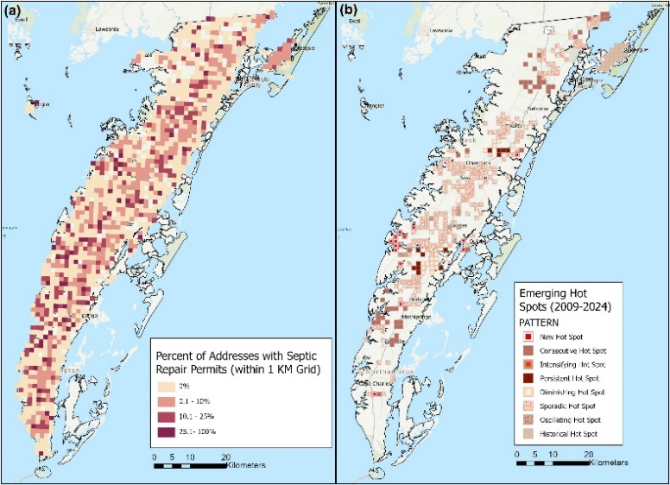
To complement physical monitoring, this task will develop a proof-of-concept early warning system that integrates sensor data with community-reported indicators to anticipate septic failures before they occur. Rather than simply flagging when failure has already happened, the goal is to predict failure risk and deliver timely, actionable alerts. To support this, we will design a simple and voluntary reporting mechanism that allows participating households to submit early signs of septic stress, such as odors, backups, soggy ground near drainfields, or changes in well water quality. These reports will be collected via mobile-friendly forms, SMS prompts, or liaison-assisted check-ins, and will help validate sensor signals, refine detection thresholds, and capture qualitative precursors that are not measurable by sensors alone. Using this combined dataset, the team will develop an AI-enabled alert system that leverages both threshold-based detection and machine learning. Thresholds will be tied to risk conditions, e.g., groundwater intrusion, drainfield saturation, or tank overload, and refined based on empirical data and community reports. Co-PI Alemazkoor will lead the development of machine learning models trained on time-series sensor data to identify patterns that precede failure and enable short lead-time alerts. The system will prioritize interpretability and uncertainty quantification to support reliability and usability. Alerts will be co-designed with participating households, with attention to delivery method, timing, and clarity. The system is intended as a community-centered, preventative tool that empowers residents to act before failures cascade into groundwater contamination, surface water pollution, or public health risks. This task builds on emerging research in hybrid ML-physical modeling and decentralized monitoring systems[20]–[22], while adapting these approaches to the novel context of septic failure.
Figure 3. Septic system hotspot analysis using septic repair permit requests submitted to VDH between 2009 and 2024 adapted from the Virginia Wastewater Data Viewer[17]. (a) shows the percent of houses within 1-KM grid that submitted repair permit requests to VDH. (b) shows emerging hot spot analysis of septic repair permits, identifying areas where septic system failures are concentrated or intensifying.
Task 2: Develop and Pilot a Decision-Support Platform for Adaptive Wastewater Transitions
Task 2.1: Model and Map Septic Failure Hotspots
We will extend the groundwater modeling framework from the ESVA Climate Equity project[16] to produce baseline maps of septic failure probability across the Eastern Shore. Using climate scenarios that incorporate sea level rise, recharge variability, and storm events, we will project how hotspots evolve at multiple horizons. Monitoring data and community-reported observations from Task 1 will be used to calibrate thresholds and validate hotspot detection under real-world conditions. Socio-demographic indicators such as income, housing tenure, and reliance on private wells will be integrated to identify disparities in exposure and adaptive capacity. This task will also incorporate and extend existing tools developed by Co-PI Mitchell. Data layers from the Virginia Wastewater Data Viewer[17], which map septic repair permits across coastal Virginia, will be integrated into the hotspot analysis to capture historical patterns of failure and repair (Figure 3). In addition, we will adapt the methodology underlying the Rural Septic Assessment platform, which evaluates suitability for community septic systems, to identify potential areas where decentralized or clustered alternatives could be most viable on the Eastern Shore. These results will identify current and future hotspots of septic failure and provide the necessary information for the decision-support platform to evaluate alternative wastewater options.
Task 2.2: Evaluate Adaptive Wastewater Alternatives
This task will co-produce a framework to evaluate various wastewater options with stakeholders and experts. We will initially consider four alternatives, including enhanced onsite systems (e.g., mounds, aerobic units, drip dispersal), clustered or community septic systems, nature-based approaches such as constructed wetlands, and sewer extensions where feasible. For each option, we will assess failure probability, risk reduction relative to baseline hotspots (Task 2.1), costs, and feasibility (both technical and regulatory) by integrating groundwater and hydrological models, engineering cost data, regulatory and permitting information, and socio-demographic indicators. The final set of alternatives and evaluation criteria will be refined collaboratively to reflect stakeholder priorities and regulatory realities. Outputs will be comparative performance profiles presenting tradeoffs across different criteria. These profiles will feed directly into Task 2.3, providing an evidence base for stakeholders and agencies to explore wastewater pathways aligned with both technical evidence and community values.
Task 2.3: Co-Develop an Interactive Decision-Support Platform
This task will co-develop an interactive decision-support platform with stakeholders and experts, ensuring that both the structure and content reflect community priorities and regulatory needs. The platform will integrate outputs from Task 2.1 and Task 2.2 into a transparent, accessible interface that allows users to explore vulnerabilities and tradeoffs across different criteria (e.g., risk reduction, cost, feasibility). Stakeholder input will guide all aspects of design, from the choice of visualization formats and levels of geographic detail to the selection of criteria and reporting functions, so that the tool directly supports decision-making processes used by households, communities, and agencies. The platform will be developed on flexible, open-source geospatial and data visualization frameworks to ensure adaptability, allowing incorporation of new data, additional system types, or updated regulatory requirements over time. The final output will be a user-tested, publicly accessible platform that enables communities and decision-makers to jointly explore wastewater adaptation pathways, translating technical analyses into actionable, co-produced knowledge for resilience planning.
Task 3: Build Foundational Data Infrastructure for Cascading Risk Assessment
This task will generate the enabling data and partnerships needed to link septic system failures to broader environmental and health outcomes in future stages of the project. We will begin by digitizing septic systems and private well records from local health departments, creating a unified geospatial database that captures system locations, installation dates, and maintenance histories where available. In collaboration with local agencies and stakeholders, we will assess data completeness and identify critical gaps, such as missing information on well depths, water quality, or septic system performance, that limit the ability to trace failures to exposure pathways. In this project, we will also identify priority locations, indicators, and protocols for future sampling efforts to be pursued. Equally important, this task will focus on strengthening partnerships with local health departments, planning district commissions, and regional collaborators such as the University of Maryland, laying the foundation for sustained data-sharing and joint development of exposure and health risk models in subsequent research. Outputs will include a digitized and quality-checked record system, a structured gap analysis, preliminary pilot data, and formalized collaborations that collectively position the project team to advance comprehensive cascading risk assessment in future work.
Task 4: Map Financing Pathways and Seed Regional Coordination for Equitable Wastewater Resilience
This task will provide the initial groundwork for advancing equitable and scalable wastewater resilience by examining financing mechanisms and regional coordination opportunities that apply to both early warning systems and adaptive wastewater transitions. We will compile and analyze existing financing pathways, including state revolving funds, cost-share programs, grant initiatives, and local permitting requirements, to assess how households and communities currently access resources for wastewater upgrades and monitoring. Special attention will be given to identifying equity gaps, such as which communities are excluded from existing programs or face disproportionate cost burdens, and to evaluating how high-cost interventions like early warning can become feasible when benefits are shared regionally. In parallel, we will engage potential partners who can help align local efforts with broader regional strategies, including organizations focused on financing equity (e.g., the Environmental Finance Center Network) as well as regional agencies and planning district commissions that can support coordination across jurisdictions. Outputs will include a synthesis of financing and permitting pathways, an assessment of key equity challenges for both early warning and system transitions, and a preliminary roadmap for regional collaboration. Together, these deliverables will lay the foundation for developing financing mechanisms and institutional structures that make wastewater resilience both equitable and scalable across the Mid-Atlantic.

Milestones, Metrics of Success, and Timeline
Progress in this project will be assessed using a combination of technical, engagement, and capacity-building metrics that reflect both scientific deliverables and community impact. Technical milestones include deployment of prototype monitoring systems, development of an AI-enabled early warning system, hotspot mapping, evaluation of adaptive wastewater alternatives, and release of a user-tested decision-support platform. Each of these outputs will be paired with quantifiable indicators, such as the number of households recruited for monitoring, accuracy and reliability of early warning signals, the completeness of digitized septic and well records, and the functionality of decision-support tools. Equally important will be qualitative measures of engagement effectiveness, such as household surveys that track changes in trust and satisfaction, usability testing of the decision-support platform, and structured feedback from local agency partners during co-design and testing. Progress in building partnerships and workforce capacity will be tracked through participation metrics, such as the number of students engaged in internships or capstone projects, the number of agencies contributing data or feedback, and through assessments of how these relationships strengthen local capacity to address septic resilience beyond the project period. More detailed mapping of these goals, milestones, and associated metrics, including community engagement (Goal 5), workforce development (Goal 6), and Climate Collaborative contributions (Goal 7), is provided in Table A.1.
To ensure that progress metrics are credible and useful, the project will establish a structured evaluation process focused on three domains: technical performance, community engagement, and workforce capacity. This process will build directly on the metrics listed in Table A.1 and will specify how data for each will be collected, refined, and analyzed. PI Shafiee-Jood, serving also as project manager, will coordinate integration of technical performance metrics. Co-PI Wilson, through the community liaison team, will lead development of community engagement metrics. Workforce capacity metrics will be developed through the ESCC partnership. In each domain, draft instruments will first be applied in early project activities, for example, initial trust surveys with participating households or pilot usability tests of early platform prototypes, and then revised based on clarity, respondent feedback, and observed effectiveness. Progress will be reviewed in bi-monthly team meetings, where results will be analyzed alongside project milestones to determine whether metrics remain appropriate and how they should be adjusted. This process makes the act of measurement adaptive rather than static, ensuring that evaluation evolves in step with project activities and community priorities. This adaptive evaluation framework, described in Section 3 and operationalized in Table A.1, also supports the development of cross-project learning activities (Goal 7).
This proposal shares the Climate Collaborative’s emphasis on co-production, interdisciplinary integration, and long-term community engagement, and we enter this effort with a unique advantage: nearly four years of experience and lessons from the ESVA Climate Equity project. Those lessons, for example in trust-building, iterative engagement, and the development of community-facing decision tools, will not only strengthen our own work but also allow us to contribute tested approaches to the Collaborative network. Furthermore, with Co-PI Mitchell’s leadership in MARISA, one of NOAA’s flagship RISA/CAP project[23], our team also brings direct connection to a decades-long tradition of translational, community-anchored climate research[24]. Building on this foundation, we propose to work with the Climate Collaborative program to design and pilot a common survey instrument for evaluating engagement practices, trust, and co-production effectiveness. We propose to deploy this instrument across current and prior Collaborative projects, creating the first longitudinal dataset of its kind. Toward the end of Year 2, we will leverage this shared effort to lead the development of a synthesis paper for submission to the Journal of Current Opinion in Environmental Sustainability. This paper will draw on survey results and comparative case analyses to identify the conditions under which collaborative, use-inspired climate research achieves legitimacy, usability, and durable community impact. In this way, our project will not only benefit from the cross-project exchange of best practices, such as data governance, equity-centered engagement strategies, and workforce development models, but also actively contribute to building the evidence base and shared scholarship that define the Climate Collaborative as a whole.

Sustainability
Sustainability has been a central concern from the outset of this project. In fact, this proposal is in many ways a direct response to questions raised during the NSF site visit for the ESVA Climate Equity project, where program officers asked how community engagement would be maintained after the project concluded and how tools like the ESVA Livability Tool would be updated beyond the award period. This project is designed to address those very issues by embedding long-term capacity, building open and adaptable tools, and charting a pathway to follow-on funding that will allow engagement and technical outputs to endure. First, the project sustains and extends community engagement by institutionalizing it within local structures. The community liaison team will continue its trusted role as the bridge between residents and researchers, while the partnership with ESCC builds a pipeline of local expertise through capstone projects and internships. These activities not only contribute to research but also create durable workforce capacity in wastewater resilience. On the technical side, the decision-support platform will be developed with open-source geospatial and visualization frameworks to ensure that it can be maintained, updated, and expanded at low cost after the initial funding. Similarly, digitized septic and well records, survey instruments for evaluating engagement, and evaluation metrics will persist as shared assets that can be further developed by local agencies and partners.
Second, the project is structured around proof-of-concept demonstrations that will provide a springboard for future funding. Within the 2.5-year award period, we will demonstrate the feasibility of monitoring and early warning systems, quantify the costs and benefits of wastewater alternatives, and produce preliminary data on cascading risks. These outputs will directly support proposals for implementation-oriented funding, such as Virginia Department of Health, Virginia Department of Environmental Quality, FEMA, HUD, USDA Rural Development, and philanthropic or industry partnerships for technology deployment. At the same time, the novel science opened up by this project, ranging from AI-enabled risk detection to integrated exposure assessment, positions the team for new federal research opportunities through NSF, NOAA, DOE, and NIH. Finally, sustainability is advanced through the explicit focus on financing and regionalization. Thrust 4 begins the process of identifying financing pathways and engaging regional partners, laying the groundwork for a Mid-Atlantic hub for wastewater resilience. Partnerships with the Environmental Finance Center Network, MARISA, and planning district commissions will provide institutional homes and regional platforms that extend the impact of the project beyond Virginia’s Eastern Shore. These collaborations ensure that what begins as a localized demonstration is positioned for equitable implementation and scale across the Mid-Atlantic. Therefore, by the end of the award period, the project will have delivered not only proof-of-concept technical systems but also the data infrastructures, evaluation frameworks, and regional partnerships needed to sustain them. In this way, sustainability is embedded in the project’s design rather than appended as an afterthought, ensuring that the benefits of community engagement, technical innovation, and institutional collaboration continue to grow long after the initial funding has ended. Table A.1 explicitly includes milestones and deliverables for sustaining project outputs beyond the award (Goal 8), ensuring that post-project maintenance, regional partnerships, and follow-on funding proposals are tracked as integral to the project rather than as afterthoughts.

References Cited
[1] M. O’driscoll, C. Humphrey, G. Iverson, J. Bowden, and J. Harrison, “Rising groundwater levels in Dare County, North Carolina: implications for onsite wastewater management for coastal communities,” J. Water Clim. Chang., vol. 15, no. 8, pp. 3666–3688, 2024, doi: 10.2166/wcc.2024.735.
[2] E. A. Albright, C. Coleman Flowers, R. A. Kramer, and E. S. Weinthal, “Failing septic systems in Lowndes County, Alabama: citizen participation, science, and community knowledge,” Local Environ., vol. 29, no. 2, pp. 135–142, 2024, doi: 10.1080/13549839.2023.2267066.
[3] L. Vorhees, J. Harrison, M. O’driscoll, C. Humphrey, and J. Bowden, “Climate Change and Onsite Wastewater Treatment Systems in the Coastal Carolinas: Perspectives from Wastewater Managers,” Weather. Clim. Soc., vol. 14, no. 4, pp. 1287–1305, 2022, doi: 10.1175/WCAS-D-21-0192.1.
[4] N. Hoghooghi, J. S. Pippin, B. K. Meyer, J. B. Hodges, and B. P. Bledsoe, “Frontiers in assessing septic systems vulnerability in coastal Georgia, USA: Modeling approach and management implications,” PLoS One, vol. 16, no. 8 August, pp. 1–24, 2021, doi: 10.1371/journal.pone.0256606.
[5] L. Sprouse, A. Kryston, S. Lebu, C. Muoghalu, C. Woods, and M. Manga, “Septic systems in North Carolina: A neglected half of the state?,” PLOS Water, vol. 3, no. 10 October, pp. 1–6, 2024, doi: 10.1371/journal.pwat.0000304.
[6] A. H. Cox, G. W. Loomis, and J. A. Amador, “Preliminary Evidence That Rising Groundwater Tables Threaten Coastal Septic Systems,” J. Sustain. Water Built Environ., vol. 5, no. 4, Nov. 2019, doi: 10.1061/JSWBAY.0000887.
[7] S. Habel, C. H. Fletcher, M. M. Barbee, and K. L. Fornace, “Hidden Threat: The Influence of Sea-Level Rise on Coastal Groundwater and the Convergence of Impacts on Municipal Infrastructure,” Ann. Rev. Mar. Sci., vol. 16, pp. 81–103, 2024, doi: 10.1146/annurev-marine-020923-120737.
[8] R. E. Threndyle, R. C. Jamieson, G. Kennedy, C. B. Lake, and B. L. Kurylyk, “Future inundation of coastal on-site wastewater treatment systems in a region with pronounced sea-level rise,” J. Hydrol., vol. 614, no. PB, p. 128548, 2022, doi: 10.1016/j.jhydrol.2022.128548.
[9] K. A. Capps, J. M. Bateman McDonald, N. Gaur, and R. Parsons, “Assessing the Socio-Environmental Risk of Onsite Wastewater Treatment Systems to Inform Management Decisions,” Environ. Sci. Technol., vol. 54, no. 23, pp. 14843–14853, 2020, doi: 10.1021/acs.est.0c03909.
[10] Eastern Shore Health District, “Eastern Shore Health District Community Health Assessment 2023-2024,” 2024. [Online]. Available: https://www.vdh.virginia.gov/content/uploads/sites/78/2024/04/ESHD-CHA-2023-2024.pdf.
[11] M. Mitchell, R. E. Isdell, J. Herman, and C. Tombleson, “Impact Assessment and Management Challenges of Key Rural Human Health Infrastructure Under Sea Level Rise,” Front. Mar. Sci., vol. 8, no. March, pp. 1–8, 2021, doi: 10.3389/fmars.2021.631757.
[12] M. Mitchell, R. Isdell, J. Herman, and C. Tombleson, “Analysis of Failed, Failing or Threatended Septic Systems in the Coastal Plain.” 2021, [Online]. Available: https://www.naturalresources.virginia.gov/media/governorvirginiagov/secretary-of-natural-resources/pdf/Septic-CBSAG.pdf.
[13] L. A. Warner, L. S. Krimsky, and S. D. Rampold, “Using a diffusion of innovation lens to understand homeowner support for septic system to sewer system conversions,” J. Environ. Manage., vol. 319, no. July, p. 115651, 2022, doi: 10.1016/j.jenvman.2022.115651.
[14] C. Jenkins and S. Delzell, “Septic Vulnerability: Essex County VA,” 2022. [Online]. Available: https://yorkriverroundtable.org/wp-content/uploads/2023/07/Septic-in-Essex_Final-Report.pdf.
[15] R. Pinkham, J. Magliaro, and M. Kinsley, “Case Studies of Economic Analysis and Community Decision Making for Decentralized Wastewater Systems,” St. Louis, MO, 2004. [Online]. Available: https://rmi.org/insight/case-studies-of-economic-analysis-and-community-decision-making-for-decentralized-wastewater-systems/.
[16] F. Hesamfar, S. A. Barbosa, T.-N.-D. Tran, T. Culver, L. Band, and V. Lakshmi, “Impact of Changing Recharge on Sole-Source Coastal Aquifer: Multi-model Assessment for Virginia’s Eastern Shore (Under Review),” J. Hydrol., 2025.
[17] AdaptVA, “Virginia Wastewater Data Viewer,” 2025. https://experience.arcgis.com/experience/4c8fea3204fd47cc842df6b0de92ee3f/page/Map (accessed Sep. 01, 2025).
[18] AdaptVA, “Rural Septic Assessment,” 2025. https://experience.arcgis.com/experience/99df401c176d4e3f91c4d2bb61a3266c/ (accessed Sep. 01, 2025).
[19] U.S. EPA, “Septic to Sewer? Justice-focused strategies for addressing coastal septic failures under sea-level rise and increased flooding,” 2025. https://cfpub.epa.gov/ncer_abstracts/index.cfm/fuseaction/display.abstractDetail/abstract_id/11353/report/0 (accessed Sep. 01, 2025).
[20] R. Bentivoglio, E. Isufi, S. N. Jonkman, and R. Taormina, “Deep learning methods for flood mapping: a review of existing applications and future research directions,” Hydrol. Earth Syst. Sci., vol. 26, no. 16, pp. 4345–4378, Aug. 2022, doi: 10.5194/hess-26-4345-2022.
[21] F. Kratzert, D. Klotz, G. Shalev, G. Klambauer, S. Hochreiter, and G. Nearing, “Towards learning universal, regional, and local hydrological behaviors via machine learning applied to large-sample datasets,” Hydrol. Earth Syst. Sci., vol. 23, no. 12, pp. 5089–5110, Dec. 2019, doi: 10.5194/hess-23-5089-2019.
[22] A. Daw, A. Karpatne, W. D. Watkins, J. S. Read, and V. Kumar, “Physics-Guided Neural Networks (PGNN): An Application in Lake Temperature Modeling,” in Knowledge-Guided Machine Learning, Boca Raton: Chapman and Hall/CRC, 2022, pp. 353–372.
[23] MARISA, “Mid-Atlantic Regional Integrated Sciences and Assessments (MARISA): A NOAA Climate Adaptation Partnership Team,” 2025. https://www.midatlanticrisa.org/ (accessed Sep. 01, 2025).
[24] A. M. Meadow, “An ethnohistory of the NOAA RISA program,” 2017. [Online]. Available: https://cpo.noaa.gov/wp-content/uploads/2023/08/Meadow_2017_RISA_History.pdf.

Appendix A

Project Goals, Milestones, Metrics, Timeline
Project Lead: Majid Shafiee-Jood
Project Title: Co-Producing Equitable Solutions to Septic System Failures: Towards a Regional Resilience Hub

Table A.1. Project goals, milestones, metrics/deliverables, and timeline. Note that metrics are tagged according to three domains emphasized in Section 3: T = Technical performance, E = Community engagement, and W = Workforce and capacity building.
Goals | Milestones | Metrics/Deliverables | Timeline
1: Demonstrate feasibility of monitoring and early warning for septic vulnerabilities | 1a. Recruit 6–10 households for monitoring demonstration (Thrust 1, Task 1.1) | Metrics: # households recruited (E); diversity of sites (T/E)  Deliverable: Household cohort established for monitoring | Y1 Q1–Q2
 | 1b. Deploy prototype monitoring systems (Thrust 1, Task 1.2) | Metrics: System reliability during storm events (T); Continuity of data streams (T); household acceptance (E)  Deliverable: Functional prototype systems installed at participating sites | Y1 Q3–Y2 Q2
 | 1.c. Develop and pilot household self-reporting mechanism (Thrust 1, Task 1.3) | Metrics: # households submitting reports (E); clarity/consistency of reports (E)  Deliverable: Working household reporting tool | Y1 Q4–Y2 Q1
 | 1d. Develop AI-enabled early warning system integrating sensor + household reports (Thrust 1, Task 1.3) | Metrics: Predictive accuracy (T); incorporation of community-reported indicators (E); interpretability of model (T) Deliverable: Prototype early warning algorithm | Y2 Q1–Q4
 | 1e. Co-design alerting protocols with participating households (Thrust 1, Task 1.3) | Metrics: Household trust/satisfaction survey (E); clarity of alerts (E)  Deliverable: User-tested alerting protocol | Y2 Q4
2. Develop and pilot decision-support tools for adaptive wastewater transitions | 2a. Extend groundwater & septic vulnerability models; map hotspots (Thrust 2, Task 2.1) | Metrics: Spatial accuracy (T); calibration against Task 1 data (T); completeness of hotspot maps (T)  Deliverable: Baseline and projected hotspot maps | Y1 Q1–Q4
 | 2b. Evaluate adaptive wastewater alternatives (Thrust 2, Task 2.2) | Metrics: Comparative profiles include failure probability (T), cost (T), feasibility (T), equity indicators (E)  Deliverable: Option evaluation profiles | Y1 Q3–Y2 Q2
 | 2c. Co-develop interactive decision-support platform (Thrust 2, Task 2.3) | Metrics: Usability scores (E); stakeholder satisfaction (E); platform functionality tests (T)  Deliverable: Beta platform for stakeholder testing | Y2 Q1–Y3 Q1
 | 2d. Public release of platform (Thrust 2, Task 2.3) | Metrics: Platform access counts (T); diversity of users (E)  Deliverable: Publicly accessible decision-support platform | Y3 Q1–Q2
3. Lay groundwork for cascading environmental and health risk assessment | 3a. Digitize septic and well records (Thrust 3, Task 3) | Metrics: % records digitized (T); completeness of database (T); agency feedback on utility (E)  Deliverable: Unified geospatial database; gap analysis | Y1 Q3–Y2 Q4
 | 3b. Identify priority sampling protocols and locations for future sampling (Thrust 3, Task 3) | Metrics: # of priority sites identified (T); stakeholder validation (E)  Deliverable: Priority site list + recommended sampling protocols | Y1 Q4–Y2 Q4
 | 3c. Formalize partnerships for long-term exposure modeling (Thrust 3, Task 3) | Metrics: # MOUs/data-sharing agreements (E/W)  Deliverable: Formal collaboration agreements | Y2 Q3–Y3 Q2

Table A.1. (Continued)
Goals | Milestones | Metrics/Deliverables | Timeline
4. Seed financing strategies and regional coordination pathways for wastewater resilience | 4a. Compile and analyze financing & permitting programs (Thrust 4, Task 4) | Metrics: Completeness of synthesis (T)  Deliverable: Financing and permitting synthesis report | Y1 Q3–Y2 Q4
 | 4b. Assess financing feasibility for early warning + transitions (Thrust 4, Task 4) | Metrics: Comparative analysis of cost-sharing models (T); stakeholder feedback (E)  Deliverable: Draft financing options report | Y1 Q4–Y2 Q2
 | 4c. Engage regional partners (EFCN, MARISA, PDCs) (Thrust 4, Task 4) | Metrics: # meetings held (E); # partners engaged (E/W)  Deliverable: Partner engagement summary | Y1 Q3–Y2 Q4
 | 4d. Develop preliminary roadmap for regional collaboration (Thrust 4, Task 4) | Metrics: Roadmap draft reviewed by partners (E); commitments to next-phase work (W)  Deliverable: Regional coordination roadmap | Y3 Q1–Q2
5. Strengthen community engagement, trust, and usability of project outputs | 5a. Conduct household trust & satisfaction surveys (Section 1.4.2, RQ-E.1) | Metrics: Baseline + follow-up survey results (E); longitudinal trust dataset (E)  Deliverable: Trust/satisfaction survey reports | Y1 Q2–Y3 Q2
 | 5b. Facilitate iterative co-design sessions for platform (Thrust 2, Task 2.3) | Metrics: # sessions (E); revisions incorporated (T/E)  Deliverable: Documented co-design iterations | Y2 Q2–Y3 Q1
 | 5c. Structured feedback from local agencies (Thrusts 2 & 4) | Metrics: # agencies providing feedback (E/W); # revisions adopted (T/E) Deliverable: Agency feedback report | Y1 Q2–Y3 Q2
6. Build durable local workforce and institutional capacity | 6a. Launch ESCC capstone projects (Section 1.4.2, Workforce) | Metrics: # projects completed (W); student evaluations (W)  Deliverable: Student project reports | Y1 Q2–Y3 Q2
 | 6b. Implement internship program with ESCC/UVA students (Section 1.4.2, Workforce) | Metrics: # internships (W); agency evaluations (E/W); student learning outcomes (W)  Deliverable: Internship reports | Y1 Q2–Y3 Q2
 | 6c. Document workforce capacity outcomes (Section 1.4.2, Workforce) | Metrics: Agency capacity assessment (W)  Deliverable: Workforce outcomes report | Y3 Q2
7. Advance collaborative learning across the Climate Collaborative network | 7a. Design and pilot survey instrument for engagement/trust evaluation (Section 3) | Metrics: # projects participating (E); survey reliability/validity (T)  Deliverable: Common survey instrument | Y1Q2–Y1 Q3
 | 7b. Deploy survey across current and prior Collaborative projects | Metrics: Response rate (E); diversity of participating projects (E)  Deliverable: Longitudinal dataset on engagement/trust | Y1 Q4–Y2 Q1
 | 7c. Lead collaborative synthesis paper (Section 3) | Metrics: Draft circulated among Collaborative PIs (E/W); submission to Current Opinion in Environmental Sustainability (T)  Deliverable: Submitted manuscript | Y2 Q2–Y2 Q4
8. Position project outputs and partnerships for long-term sustainability and scaling | 8a. Maintain/update decision-support platform post-award (Section 4, Thrust 2) | Metrics: # updates integrated (T); continued community use (E)  Deliverable: Post-award update plan | Y3 Q1–Y3 Q2
 | 8b. Formalize partnerships for Mid-Atlantic regional hub (Section 4, Thrust 4) | Metrics: # MOUs/agreements signed (E/W)  Deliverable: Regional hub partnership agreements | Y3 Q1–Y3 Q2
 | 8c. Identify and prepare follow-on funding proposals (Section 4) | Metrics: # proposals submitted (T/W); diversity of funding sources (federal, state, industry)  Deliverable: Submitted funding proposals | Y3 Q1–Y3 Q2

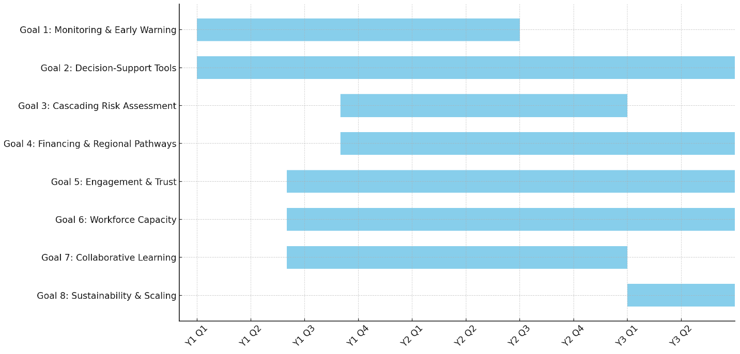
Figure A.1. Proposed timeline of project goals

